ABHINAV EDUCATION SOCIETY’S

College of Computer Science & Management

Ambegaon(BK) Pune -411046



**A PROJECT REPORT ON**

DENTAL MANAGEMENT SYSTEM

**SUBMITTED BY**

**Miss.Rucha Goraksh Sangale.**

**Mrs.Tabssum Isa Ansari.**

**IN PARTIAL FULFILMENT OF THE REQUIRMENT FOR THE AWARD**

**OF**

**B.C.A (BACHELOR OF COMPUTER APPLICATION)**

**UNIVERSITY OF PUNE**

**GUIDED BY**

**Mrs. Rachana Chavan-Shinde**

**ACADEMIC YEAR 2019-2020**

ABHINAV EDUCATION SOCIETY’S

College of Computer Science & Management

Ambegaon(BK) Pune -411046



**Exam Seat No: Date :**

**DEPARTMENT CERTIFICATE**

This is to certify that Mr./Ms. Rucha Goraksh Sangale and Tabssum Isa Ansari for T.Y.BBA(C.A) has Successfully completed Software Project Dot Net Technology Syllabus prescribed by the Savitribai Phule Pune University during the academic year 2019- 2020 and this Report represents Her Bonafied work.

**Project Guide Principal**

**Internal Examiner External Examiner**

**Date:**

**ACKNOWLEDGEMENT**

We take this great opportunity to acknowledge everyone who has been involved in the creation of this project. We would firstly like to thank Mrs. Rachna Shinde mam for letting us this great opportunity to test our skills through the creation of our project as part our syllabus.

Our sincere thanks and gratitude should go towards the faculty of our college for their kind co-operation and attention for the creation of this project.

Special thanks must go to our college. And allowing us to develop our own ideas and creations towards the development of our project.

Further, we wish to thank all Teachers, persons, who knowingly or unknowingly helped us in completion of this project.

If something is left inadvertently, we are sorry for that.

Thankyou.

**Index**

|  |  |  |
| --- | --- | --- |
| **Sr.no** | **Title** | **Page no** |
| 1. | **INTRODUCTION**  1.1 Introduction to System  1.2 Existing System  1.3 Need of System  1.4 Proposed System  1.5 Scope of System  1.6 Objective of System |  |
| 2. | **ANALYSIS**  2.1 Feasibility Study  2.2 Fact Finding Technique  2.3 Hardware Requirement  2.4 Software Requirement |  |
| 3. | **SYSTEM DESIGN**  3.1 E-R Diagram  3.2 Data Flow Diagram |  |
| 4. | **FORM DESIGN**  4.1 Screen Shots  4.2 Data Report |  |
| 5. | **SYSTEM TESTING**  5.1 Testing  5.2 Testing Objectives  5.3 Test Plan  5.4 Testing Methodology |  |
| 6. | **Advantages and Limitation** |  |
| 7. | **Future Enhancement** |  |
| 8. | **Conclusion** |  |
| 9. | **Bibliography** |  |

1.

INTRODUCTION

* 1. **INTRODUCTION:**

Dental Clinics, Dental department or other specialty department in a general hospital can use this software. Though this software was designed primarily with the inputs from dental Clinics, it could be adoptable in other specialty hospitals also, with some little changes in the medical terms, database etc.

DCMS software has been developed to provide comprehensive software solution for the clinics. But there are clinics that cannot afford to run such comprehensive system or may not be required due to the volume of work handled. Still to encourage such clinics to use computers for generating useful information to run the organization efficiently, we provide the following Software from which one can choose according to their requirement. It is a system which will help dentist to keep track patient dental problems, from time to time. This system helps to maintain available patient details, add, update, and delete records. It also makes the fee instalment details.

The software is designed systematically. This software provides with lots of user friendly environment. The data regarding the patient dental information will help the patient in order to apply for the next treatment and also to be use for the future. The reports able to summarize the patient dental healthcare performance from time to time according to the treatment made. Other than help the patient to upgrade their awareness regarding the oral health, these reports will also give benefits to patients as they can view their dental health performance.

**1.2 EXISTING SYSTEM:**

Existing system refers to the system that is being followed till now. Presently most of the clinics functionalities are done manually. That is if a patient want to consult a doctor he can visit their till his chance called. This is making the person very difficult. An Appointment is distributed directly. The main disadvantage is time consuming. Limitation of existing system is if some patient loses his receipt, difficulties to find out patient has assign tickets. To defect this limitation we do computer system. The current system works as the following:

* In the old system, the user was maintaining the records like number of Appointments, patients.
* Fees Detail and bill (Receipt) in the paper sheets.
* Hence it little bit difficult to keep track which patient has been taken which appointment on which day, what is the Bill no, etc.
* The manpower required for this kind of transaction and maintenance of data is higher than the actual requirement.

**1.3 NEED OF SYSTEM :**

As we were studied the existing manual system, we were found number of limitations in this system. (i.e. User Manual System) And never helps for fast decision making, the process is very slow which consumes lot of time etc.

To avoid these limitations there is a need of producing the system which should be user friendly, easy to maintain and store the related information or data, easy to reproduce the stored data, helps in making fast decisions and the whole process should be faster than the existing manual system. Our software has the facility to give a unique id for every patient and stores the details of every patient*.*

**PROPOSED SYSTEM:**

The DENTAL CLINIC MANAGEMENT SYSTEM software is user-friendly software. The system is very simple in design and to implement. The system requires very low system resources and the system will work in almost all configurations.

**1.4 Scope of the system:**

The software is used in dental clinic to maintain the records of patients in advanced fashion instead of paper document.

It also includes appointment schedule. It is easy to search and retrieve the information stored, related to patients when the patient visited more than once. So that the time required for searching the paper documents of the patient will be saved. Previous medical records are used to manage documents of patients visited earlier.

Dental Software is designed and built to meet all the requirements of a dental clinic and to help the dentist in managing their clinics in an effective manner. With just a few clicks the user can schedule faster, record treatment plans easier, simplify billing.

Our project aims at creating an application which will automate the process in Dental Software. Using this it is possible to keep a track of a database for clinic like information about the patient like appointment schedule, personal records, previous medical records, treatment records, prescriptions, case reports and images. The dental software is used for collecting, managing, saving, and retrieving medical information for the patients, and for creating reports for the patients. Patient records are used by the dentists in order to organize the records of the patients in their practice.

**1.5 OBJECTIVE OF THE SYSTEM:**

Our main aim of the project is to get the correct information about particular Patient and to reduce human efforts. The user can maintain all the records about Patient Details, Appointments, Doctor Details, Follow-ups and Bill and save it in the database. Enable the clinicians and administrators to search documents and records by criteria such as patient name, patient id, and address. The goals that wish to be achieved are:

1. System manages to save all the patient record accurately and computerized.
2. System able to avoid the data redundancy of patient dental information.
3. System manages to check the available date and time to make appointment between dentist and patient.
4. System able to display patient dental history and treatment that had been done.
5. Generate report of patient dental condition according to the treatment session.
6. Generate statistic report regarding number of patient visit for treatment at the clinic.

2.

ANALYSIS

Feasibility STUDY

**2.1 FEASIBILITY STUDY:**

A feasibility study is conducted to select the best system. That meets performance requirement. A system required performance is defined by a statement of constraints the identification of specific system objectives & a description of outputs. All projects are feasible-given unlimited time.

**ECONOMICAL ANALYSIS:**

 A system is expected to provide benefits. As assessment of the economic justification for a computer based system project is cost benefit. The proposed system is economically feasible because the cost involved in purchasing that hardware and the software are within approachable. The personal cost like salaries of staffs hired are also nominal, because working in this system need not required a highly qualified professional.

**TECHNICAL ANALYSIS:**

This hardware was already available on the existing computer. System the software like Microsoft Access , Visual Studio 6.0, MS-Word and operating system used the were already installed on the existing. So no additional hardware and software required to purchase and it is technically feasible. So not of much effort was put for technical analysis*.*

**BEHAVIOURAL ANALYSIS:**-

Behavioural analysis is an operational principle for all requirements analysis methods. An estimate should be made of how strong a reaction the user is likely to have towards the development of a system. This project is based on Offline that’s why most of the dentists who want the paperless work can easily adopted the system because it has become very easy for the user to use this system.

Fact-finding Techniques

**2.2 Fact-finding Techniques:**

Fact finding is process of collection of data and information based on techniques which contain sampling of existing documents, research, observation, questionnaires, interviews, prototyping and joint requirements planning. We have used suitable fact-finding techniques to develop the system.

## Sampling of existing documentation, forms and databases:

The best way to analyse the existing system is to collect facts from existing documentation rather than from human sources.

* Samples of completed manual forms and reports and
* Samples of completed computerized forms and report.
* Existing program documentation*.*

## Interviews:

Interview is the most commonly used technique to collect information from the face-to-face interviews. The purpose of interview is to find, verify, clarify facts, motivate end-users involved, identify requirements and gather ideas and opinions. So we interviewed a dentist who answered for our questions such as “how he wants the software?””what are his requirements” and so on.

## Observation of the work environment:

## Another fact finding technique is observation. This technique helped in understanding the problem facing for storing data about Members with manual system for long period of time by interacting with the user.

Hardware Requirement

Software Requirement

Hardware Requirement

**2.3 Hardware Requirement:**

The proposed system is very much in line with the existing system in terms of its requirement. The requirement of proposed system in terms of hardware resources and software platform and utilities is listed below.

1. RAM: - 128 MB.

2. About 500 MB free Hard disk space for safe operation.

Software Requirement

**2.4 Software Requirement:**

1. Operating system: - Windows –7.

2. Front End: - Microsoft Visual Studio 2010

3. Back end: - Microsoft-Access

The requirements of the system listed above are the minimum requirements that are needed for the operation of the system at site.

3.

SYSTEM DESIGN

E-R Diagram

Data flow diagram

3.1 E-R Diagram

Takes

Requires

IS A

Gives

Takes

Receptionist

Gives

Patient

m m

Treatments

Takes

m m 1

Dentist

Patients

Pays

m

m 1

Appointments

m 1

1 m m

Maintains

Record

Product Name

Treatment info

Prescription info

Lab info

Product Quantity

Product

Product Rate

Medicine management

Patient management

Dental

Clinic

Appointment management

Dental problem management

Generate bill

Generate patient Report

Treatment management

Patient management

Dental

Clinic

Generate dental problem

Check appointment details

Dental problem management

Appointment management

Admin

Manage cash report

Check roll access

Login to system

New registration

Appointment

Manage patient details

Check credentials

Manage modules

Treatment

Manage system admin

**1.Flasscreem**

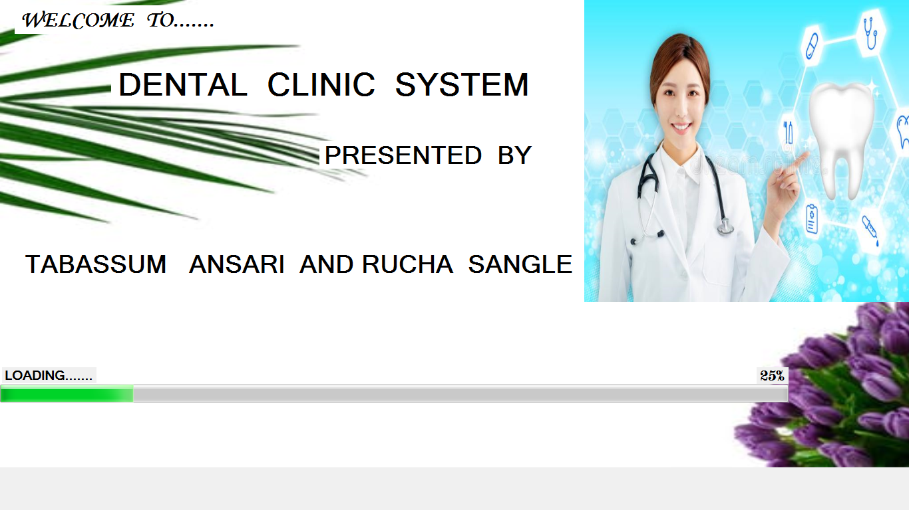

**2. login**

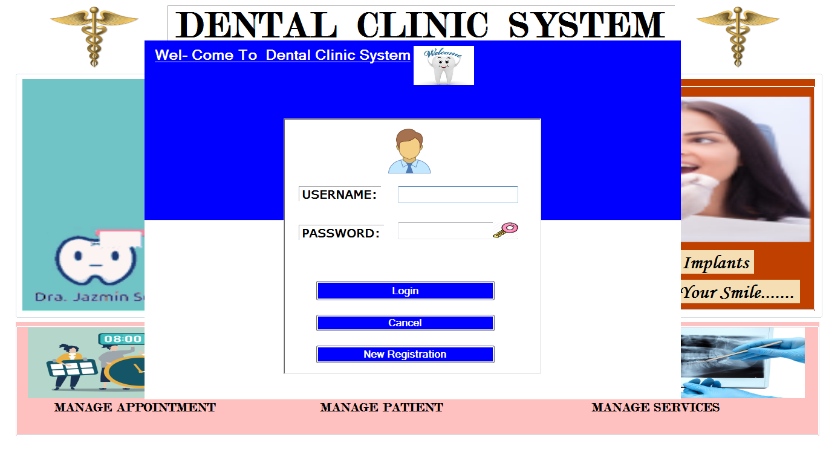

**3.main page**

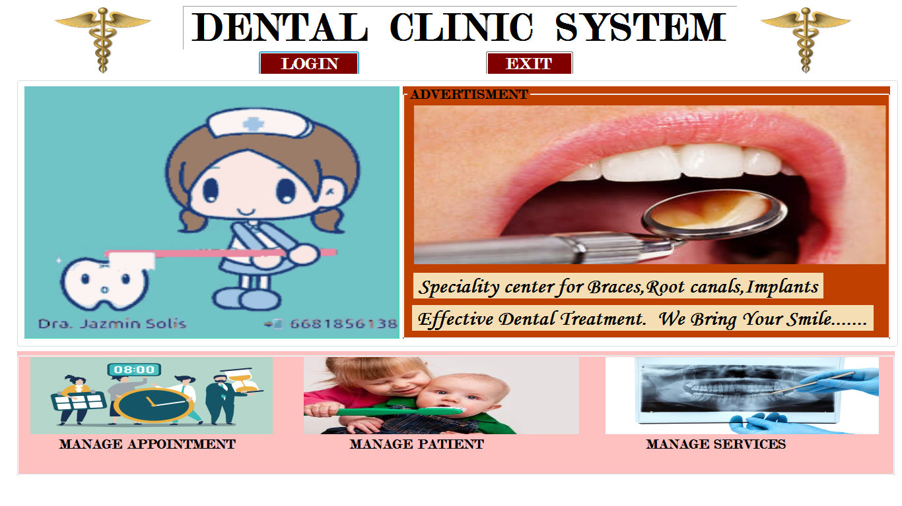

4.presciption form

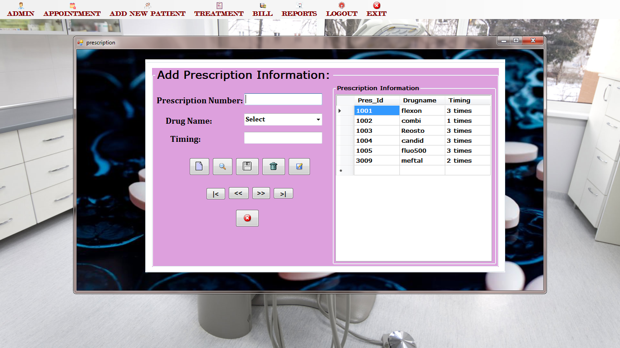

5.home page 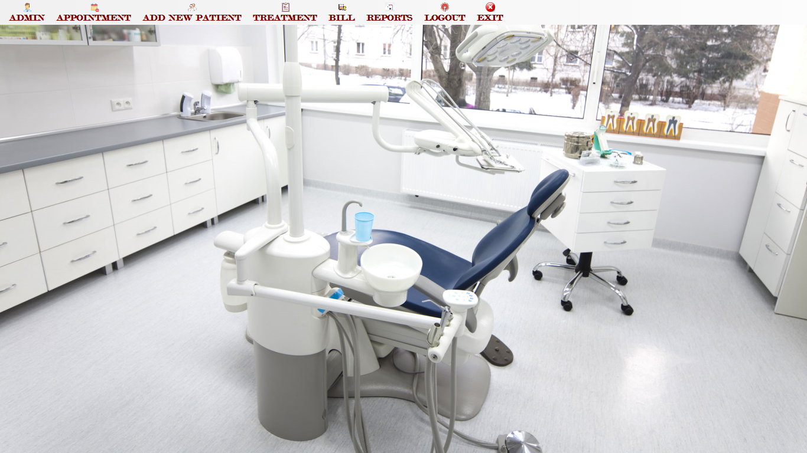

6.treatment page

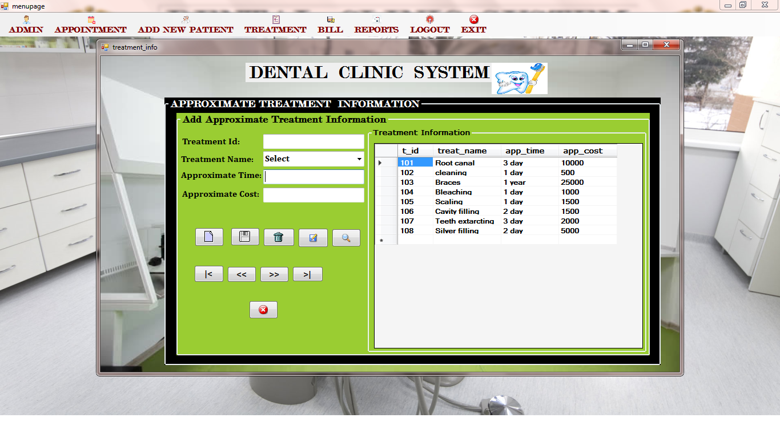

7.lab page

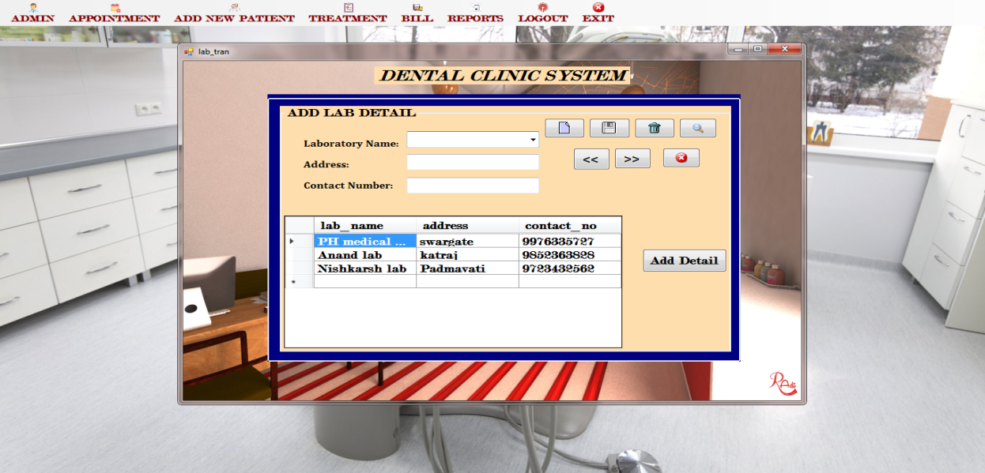

8. Purchase page

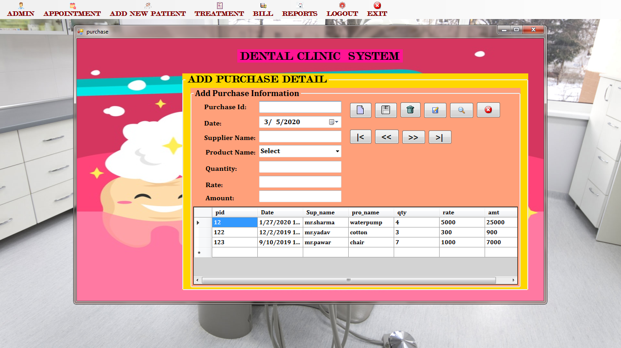

9.staff page

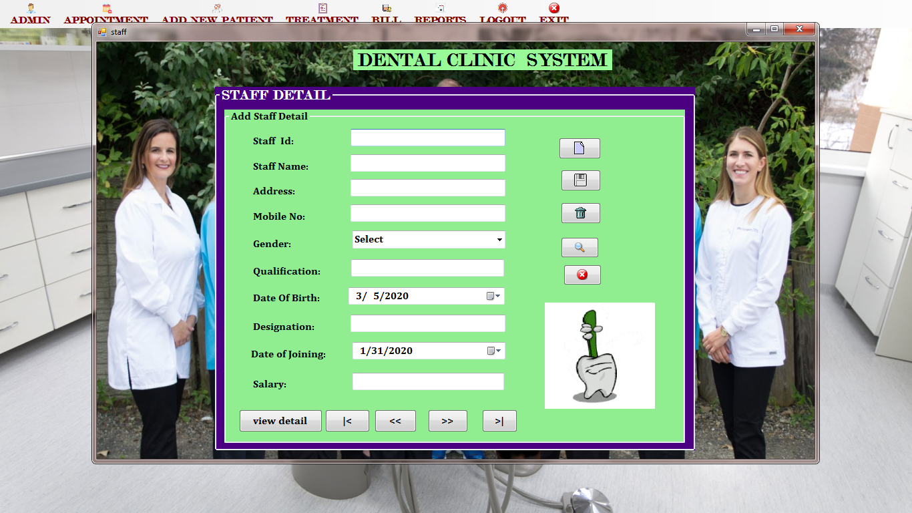

10,appointment page

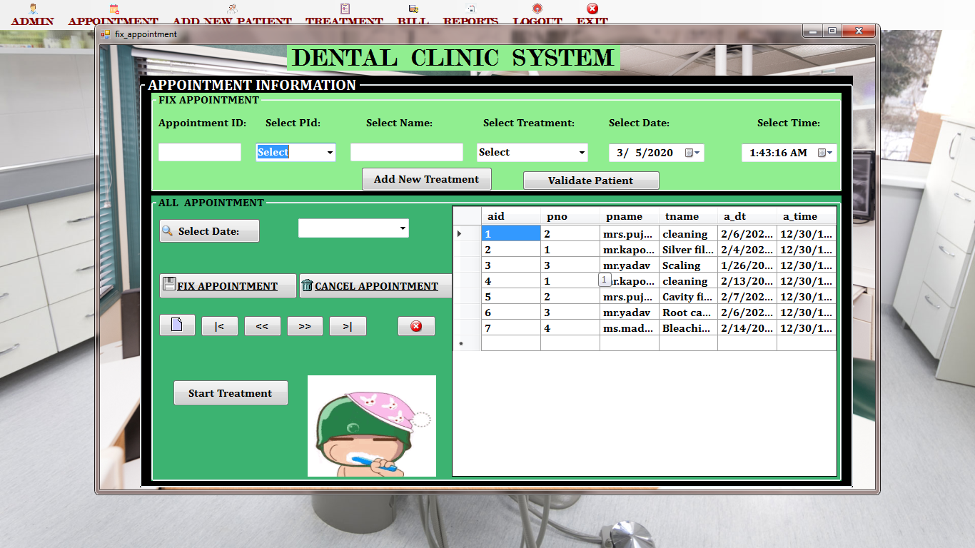

11.patient page

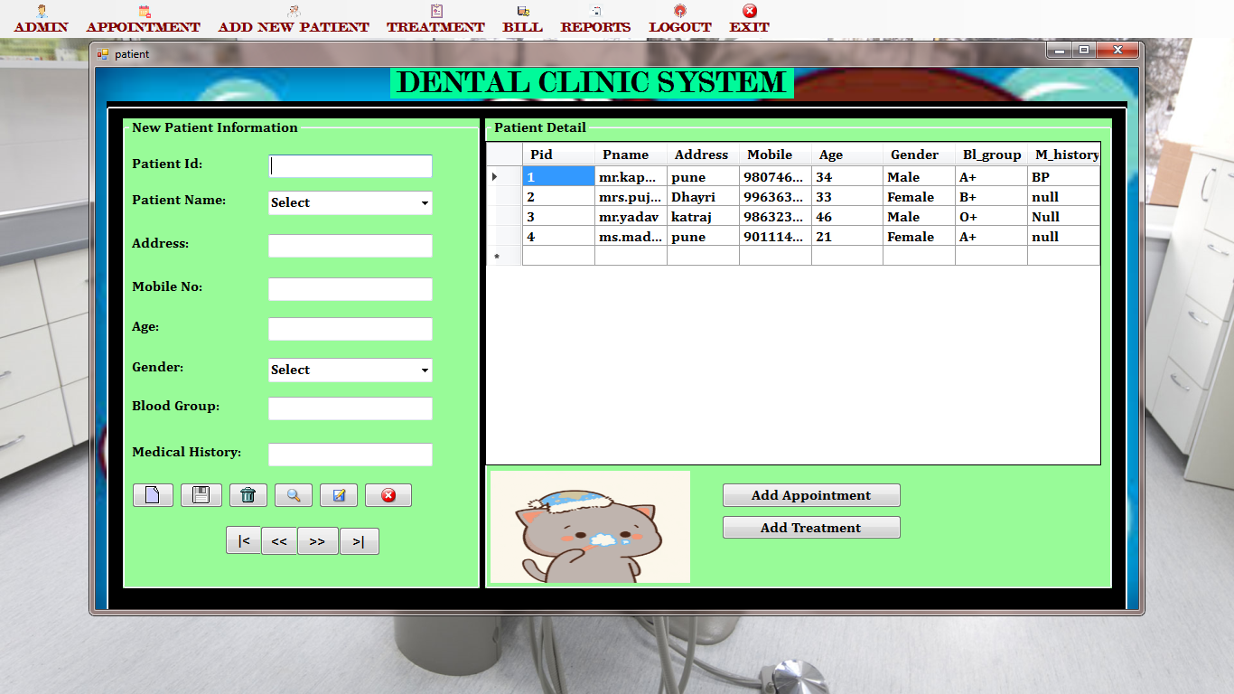

12.treatment page

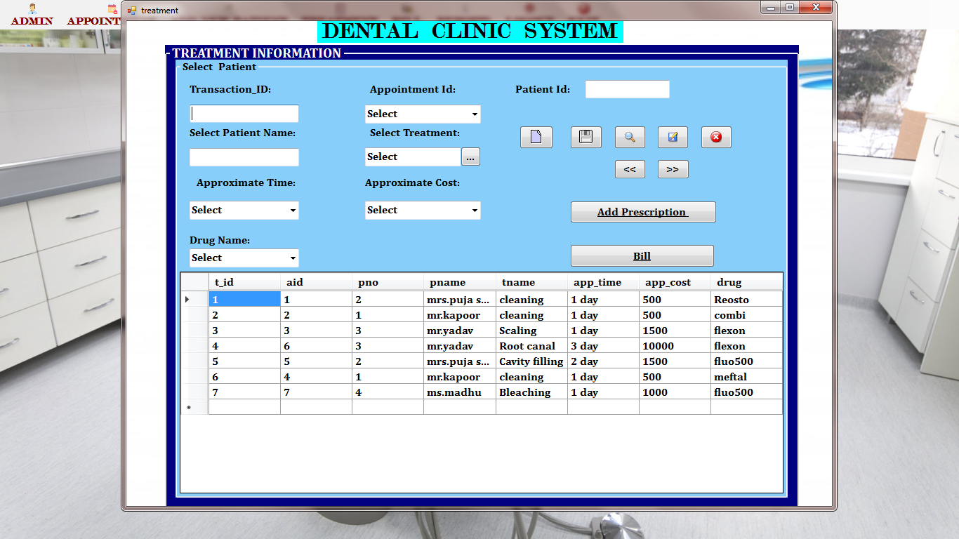

13.bill page

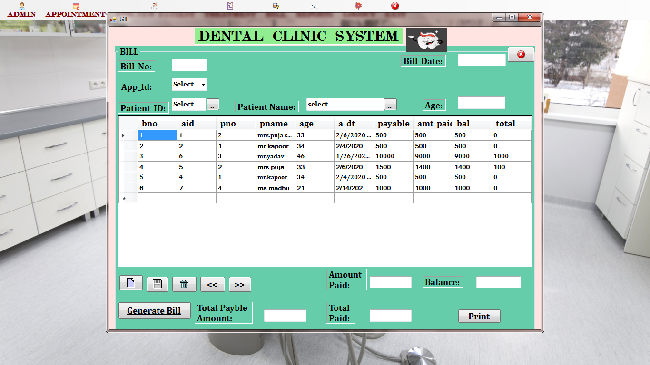

14.patient report

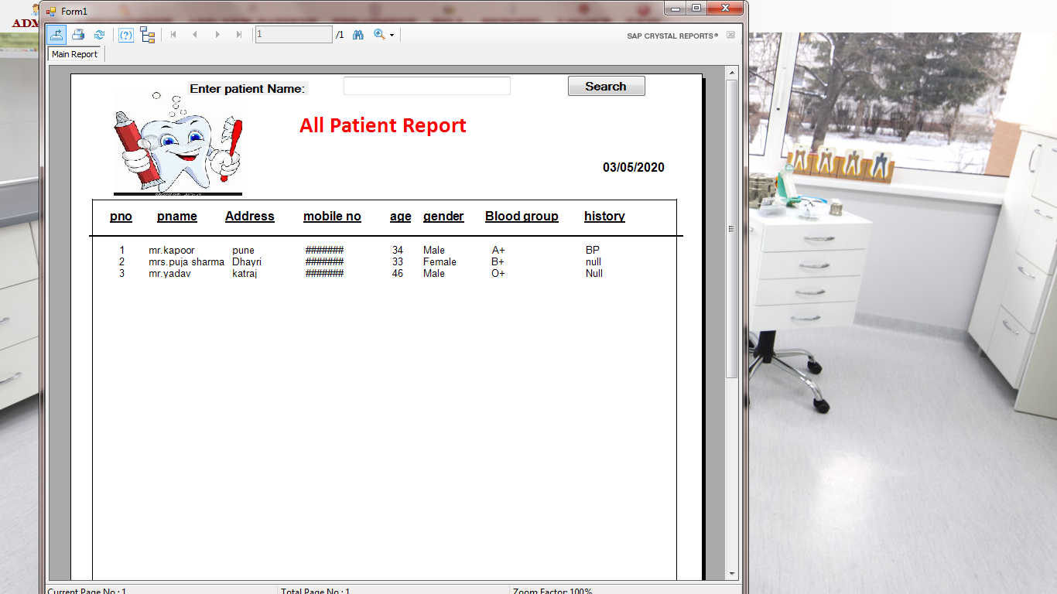

15.appointment,treatment report and last page

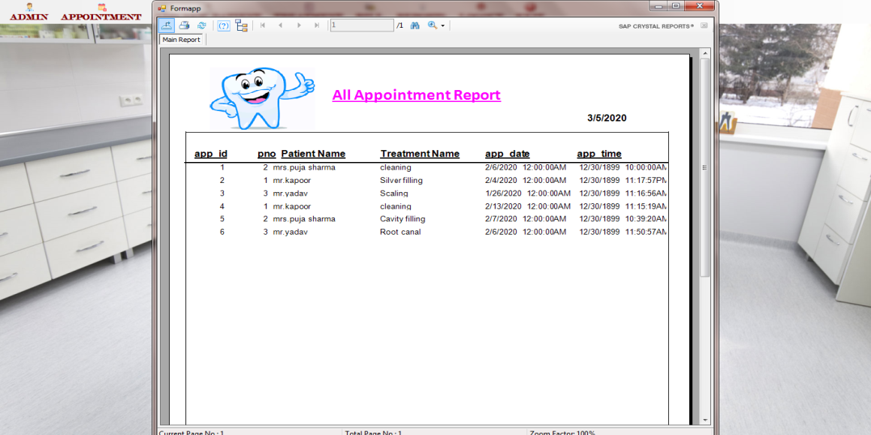

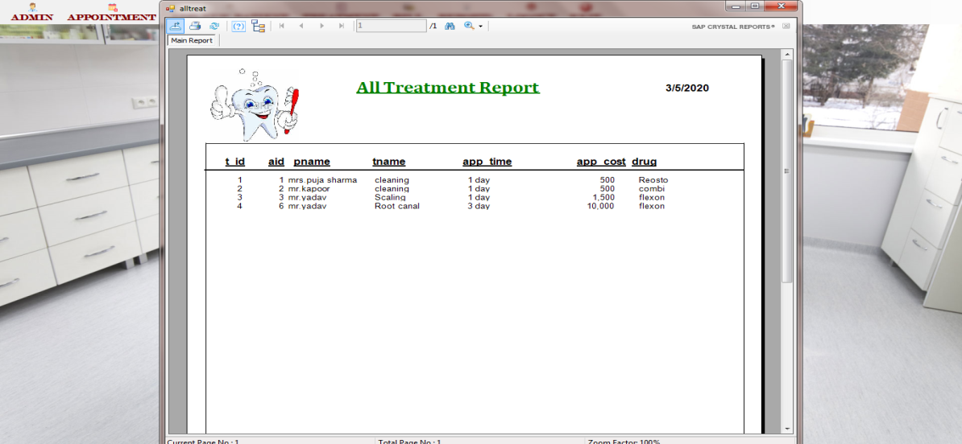

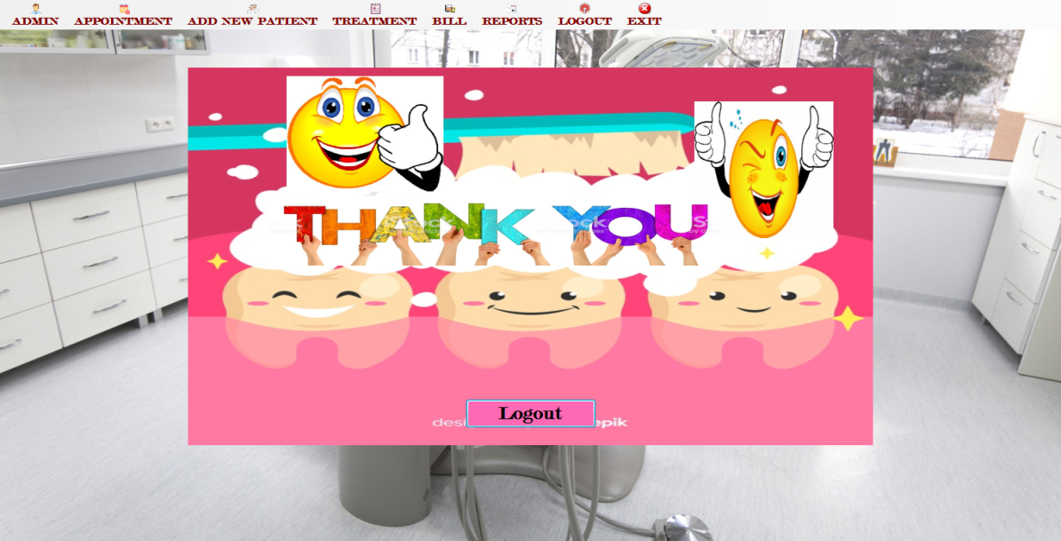

4. Data report

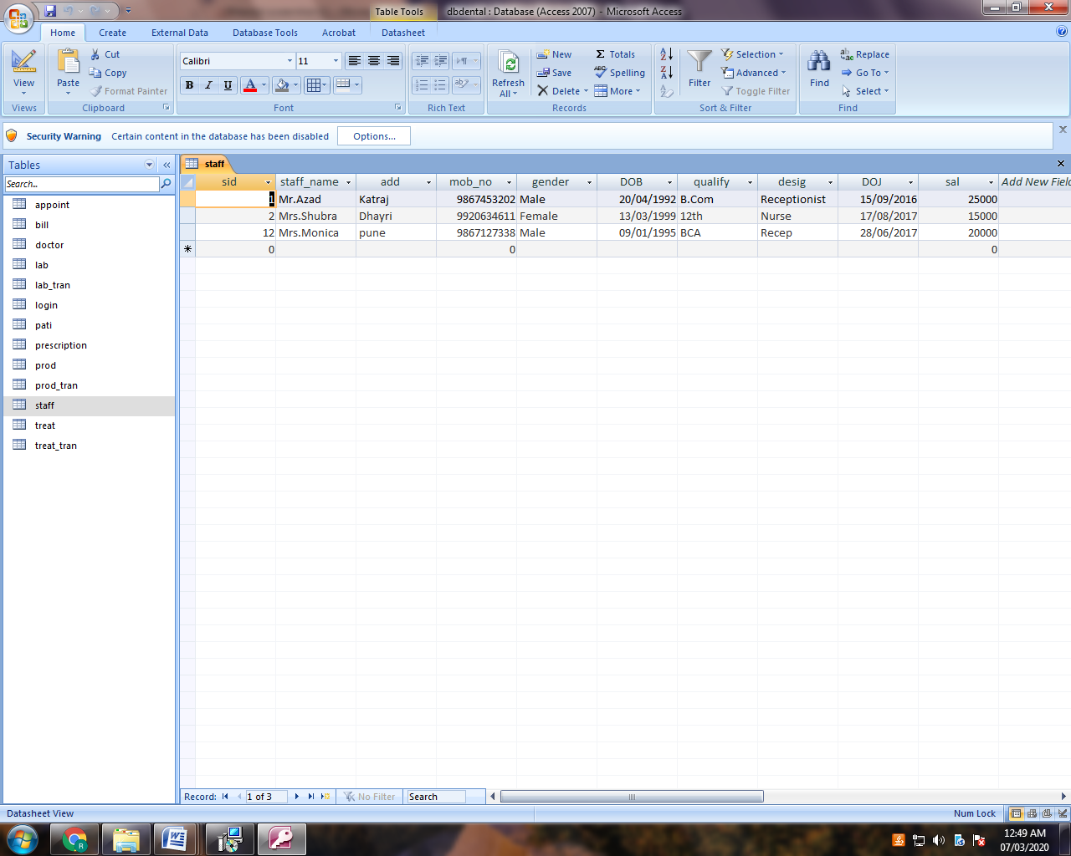

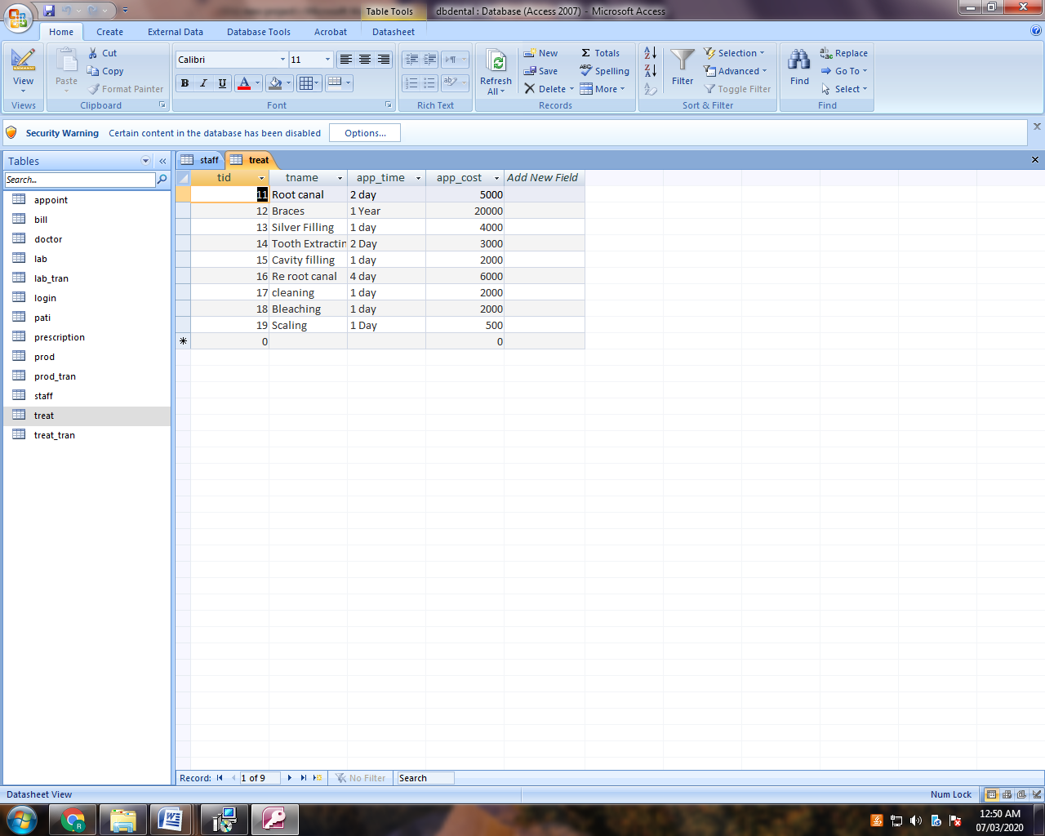

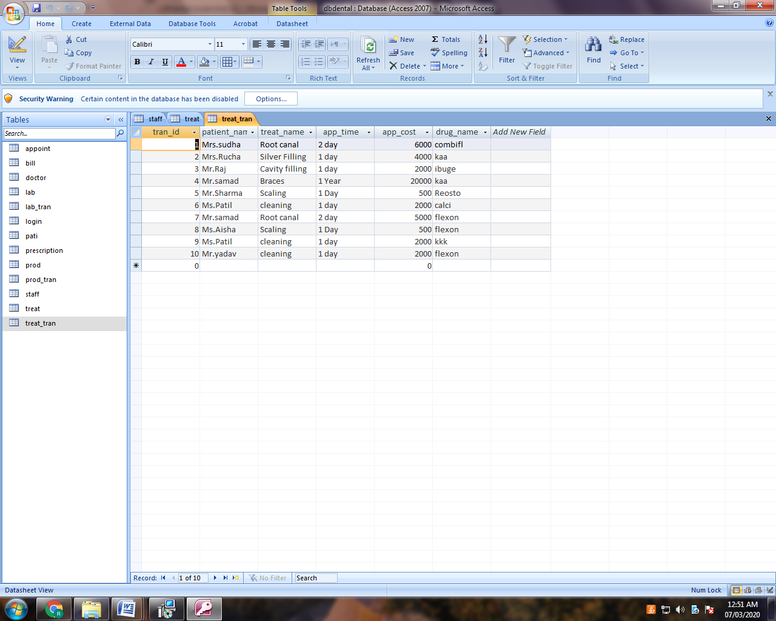

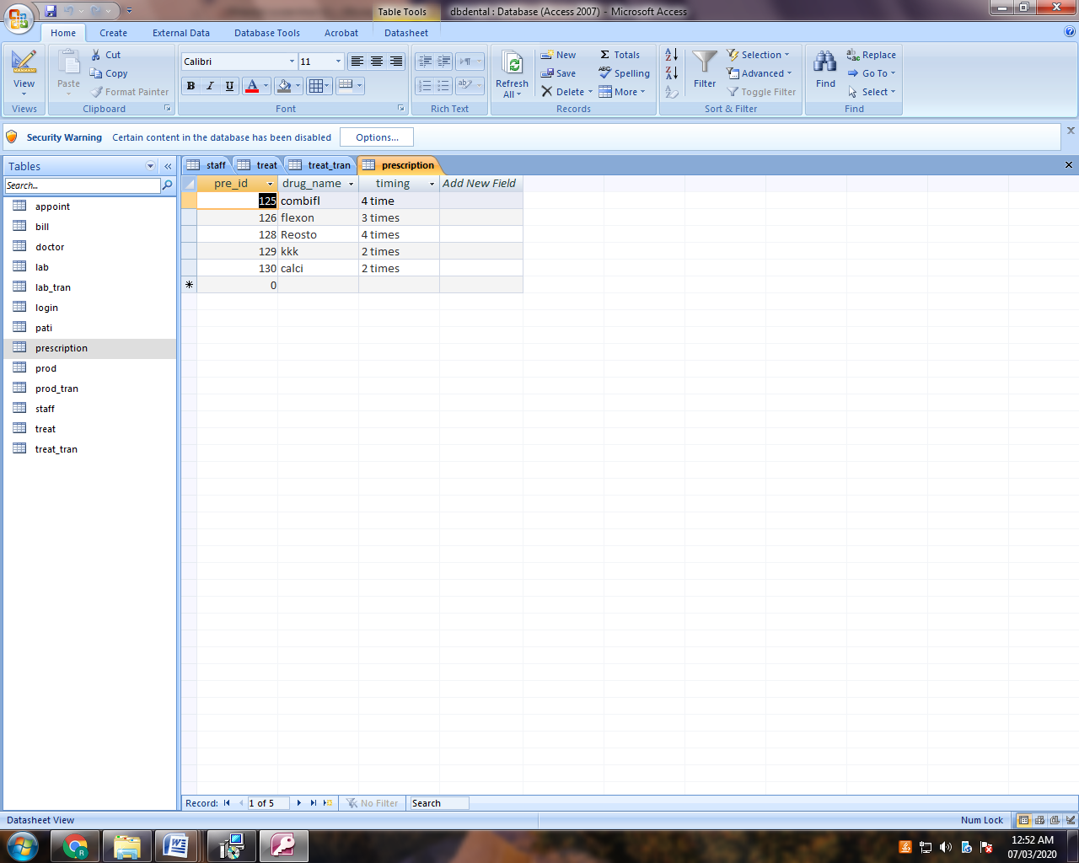

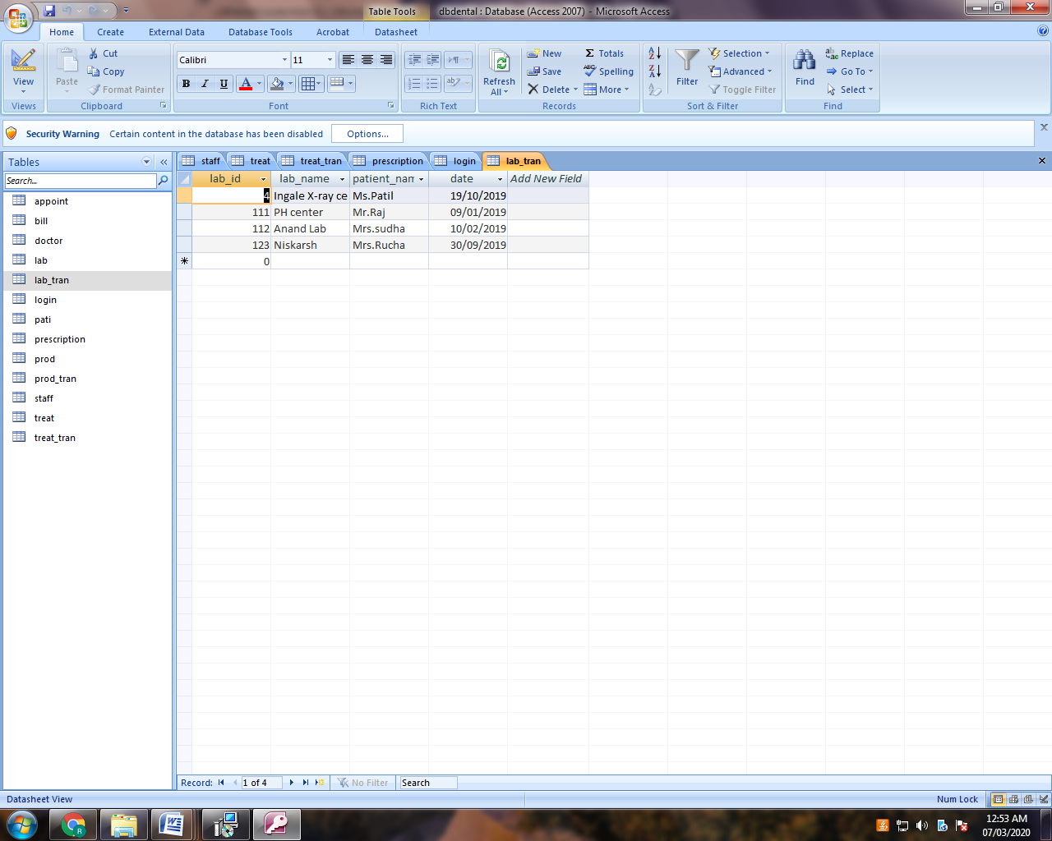

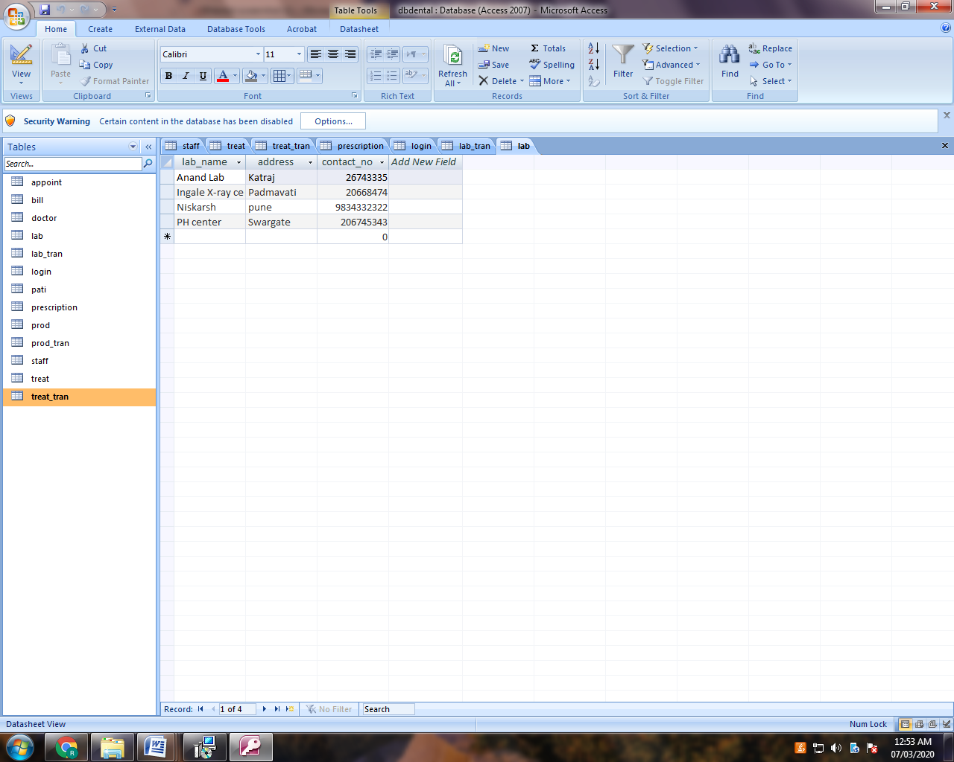

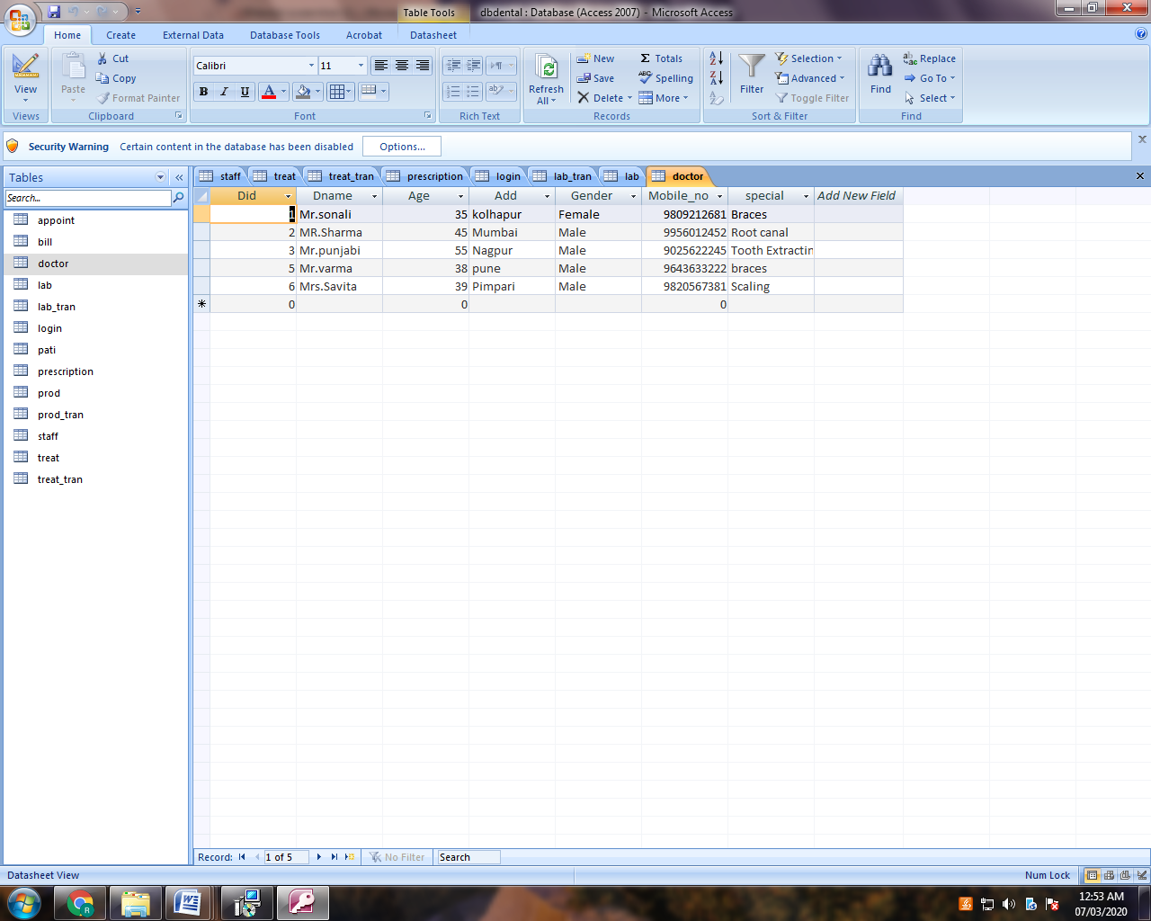

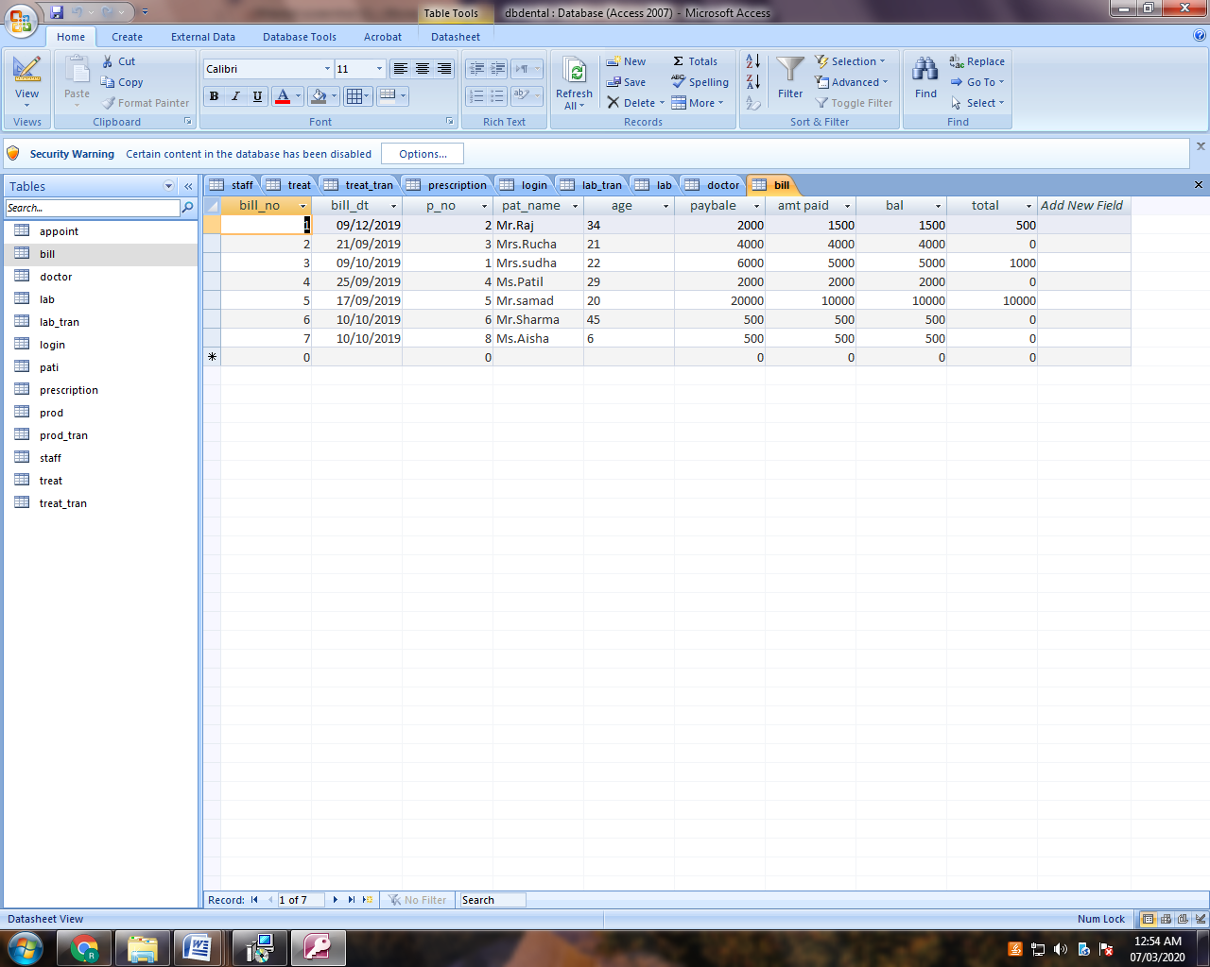

5.

SYSTEM TESTING

**5.1 TESTING:**

Testing is the most vital phase in completing a project. Testing mainly aims at checking the modularity, data flow and code thereby scrutinizing the intricacies of the system being developed. At all the required places appropriate validation has been done. User involvement at every stage has been propounded in the system. Testing is the crucial part of the system development to assure quality of the services, design and coding.

Testing Objectives

**5.2 Testing Objectives:**

Testing objective is the guideline that helps in carrying out  proper testing of the system. The guidelines stated below are followed to carry out proper testing on the system. Testing is the  process of executing a program with a goal to uncover the errors within the system. A successful test needs to be carried out in order to find undetected errors. The main objective is to design the tests that systematically uncover different types of errors with minimum amount of time and errors. Testing demonstrates that the system functions appear to be working in a proper manner and that the performance requirements are met.

Test Plan

**5.3Test Plan:**

Test plan provides a road map for instituting software testing. This describes the overall testing strategy and the project management issues that are required to properly execute effective tests. Testing plan contains various test phases, start and end dates for each phase is described. Testing is the process of analyzing a software item to detect the differences between existing and required conditions and to evaluate the features of the software item.

Testing Methodology

**5.4Testing Methodology:**

* **Blackbox testing:**

The first type of testing was at user level where all the applications were tested for the users*.*

* **WhiteBox Testing:**

The second level of testing was at functional level where each module of all the applications was tested. This testing continued throughout the entire project, evolving from component level (or unit) testing to integration testing.

* **Unit Testing:**

This testing focuses effort on the smallest part of software design-the module or software component. After the code has been developed, reviewed and verified for correspondence to component level design, unit testing case design begins.

* **Integration Testing:**

Unit testing ensures that all the modules are working fine independently but now we have to test the system as a whole; we have to develop a strategy, which sees that the system is functioning properly as a whole system. Integration testing is systematic testing for constructing the program structure while at the same time conducting tests to uncover errors associated with interfacing. We will use bottom up integration testing where we will integrate the modules by starting with the lower individual modules and moving upward through the control hierarchy*.*

6.

Advantages

And

Limitation

**LIMITATIONS OF EXISTING SYSTEM:**

 No system can be referred as complete system in all aspects. In spite of successful executions of testing plan .The problem arises, when the system is input in the real working environment, the problem that will arise cannot be visualized and their solution cannot be predetermined to be rectified.

* The designed product is stand alone system.
* It works on current basis.
* On-line booking, transaction etc are not possible.

**ADVANTAGES OF PROPOSED SYSTEM:**

The system is very simple in design and to implement. The system requires very low system resources and the system will work in almost all configurations.

* Security of data.
* Ensure data accuracy’s.
* Administrator controls the entire system
* Minimize manual data entry.
* Greater efficiency.
* User friendly and interactive.
* Minimum time required*.*

**7.**

**Future**

**Enhancement**

**Future scope of the Project :**

* Implementing, sending the reports through mail to the patients.
* And helps the doctor to maintain the best relationship with their patients.
* And the patients can be able to take online appointments.

8.

CONCLUSION

**CONCLUSION**

Dental Management System is a system which is a first step to change the medical industry methodology of keeping the data of patients as well as the other important information. This system will help the users to manage the dental information and make sure that all the important data are able to be use in the future time. This includes information for the future treatment, as well as to do research from the data that had been captured. As this system will be used for the dental management, the dental industry will soon be a high standard industry, which all the process will be done through the computer and specified system. I actually learnt what exactly coding is when I did this project in Microsoft Visual Basic 6.0 & MS Access. It was different from what you read in books. It was a great learning process.

9.

BIBLIOGRAPHY

**BIBLIOGRAPHY:**

* **Text-Book References:**

* ***Software Engineering Vision Publication.***
* ***VB.NET textbook and reference book***

* **Web references:**
* www.google.co.in
* [www.stackoverflow.com](http://www.stackoverflow.com)
* www.studentprojectcode.com